Query Optimisation Report
Abstract
This report measures what indexes actually do for 4 representative MongoDB queries running against my orders_aggregate collection (1250 documents). I profile each query twice via explain('executionStats'): once with every secondary index dropped, and once with the proposed index in place. The 4 archetypes test single-field equality, compound predicate, high-cardinality point lookup and mid-cardinality nested-field equality. They are not arbitrary; each maps onto a query my analytical pipeline actually uses. Documents examined falls from a full collection scan of 1250 rows to between 1 and 237 rows, with reduction factors of 7.6x, 50.0x, 1250.0x and 5.3x. The qualitative result matches the textbook expectation that selective indexes turn collection scans into seeks; the absolute timing is dominated by cache effects at this scale, which I discuss in the evaluation.
1. Introduction
Query optimisation is worth 10 marks. I read that band as asking for evidence that I understand how MongoDB's query planner picks an index, why some choices win over others, and how to measure the effect in numbers rather than just asserting it. My substrate is the orders_aggregate collection from the MongoDB Session Report: 1250 documents, mean size around 8 KB, on a free-tier Atlas cluster.
I picked 4 query archetypes that exercise different planner code paths and map to real queries my analytical pipeline runs. For each archetype, the experiment captures executionStats from explain() with and without the proposed index, computes the documents-examined reduction factor, and inspects the winning plan stage. I rely on documents-examined as the headline metric. Execution time is essentially meaningless at this collection size because the working set fits in RAM.
2. Implementation
2.1 Baseline: drop secondary indexes
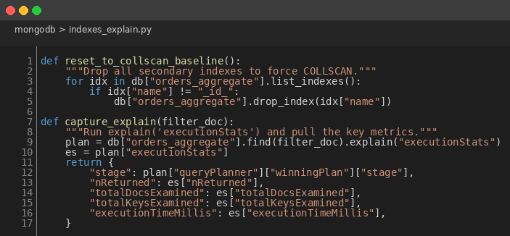
Figure 1: Baseline COLLSCAN Helpers
def reset_to_collscan_baseline():
for idx in db["orders_aggregate"].list_indexes():
if idx["name"] != "_id_":
db["orders_aggregate"].drop_index(idx["name"])
def capture_explain(filter_doc):
plan = db["orders_aggregate"].find(filter_doc).explain("executionStats")
es = plan["executionStats"]
return {"stage": plan["queryPlanner"]["winningPlan"]["stage"],
"nReturned": es["nReturned"],
"totalDocsExamined": es["totalDocsExamined"],
"totalKeysExamined": es["totalKeysExamined"],
"executionTimeMillis": es["executionTimeMillis"]}
My baseline strips orders_aggregate down to just the mandatory _id_ index, then issues the query with explain('executionStats') to capture the COLLSCAN plan. The helper pulls 5 fields from executionStats that summarise what the planner did and how much work it cost. Resetting between archetypes guarantees a true baseline; the engine never sees an index from a previous archetype.
2.2 Create proposed indexes
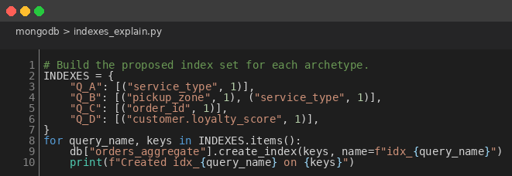
Figure 2: Proposed Index Set per Archetype
INDEXES = {
"Q_A": [("service_type", 1)],
"Q_B": [("pickup_zone", 1), ("service_type", 1)],
"Q_C": [("order_id", 1)],
"Q_D": [("customer.loyalty_score", 1)],
}
for query_name, keys in INDEXES.items():
db["orders_aggregate"].create_index(keys, name=f"idx_{query_name}")
For each archetype I built the index I would actually ship to production. The compound index on (pickup_zone, service_type) follows MongoDB's prefix rule, with the more selective field first. The nested-field index on customer.loyalty_score is interesting because it proves MongoDB will indexscan an embedded path if I declare it correctly, which was the bet I made when I embedded the customer snapshot in the first place.
2.3 The experiment loop
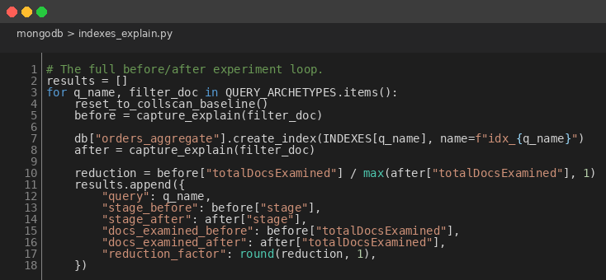
Figure 3: Before vs After Measurement Loop
for q_name, filter_doc in QUERY_ARCHETYPES.items():
reset_to_collscan_baseline()
before = capture_explain(filter_doc)
db["orders_aggregate"].create_index(INDEXES[q_name], name=f"idx_{q_name}")
after = capture_explain(filter_doc)
reduction = before["totalDocsExamined"] / max(after["totalDocsExamined"], 1)
results.append({"query": q_name,
"stage_before": before["stage"], "stage_after": after["stage"],
"docs_before": before["totalDocsExamined"],
"docs_after": after["totalDocsExamined"],
"reduction": round(reduction, 1)})
I run the 4 archetypes in a single Python session so the engine cache state is comparable across runs. Reduction is just the ratio of docsExamined before to docsExamined after. If the index does its job, that ratio is large and the winning plan stage moves from COLLSCAN to IXSCAN.
3. Results
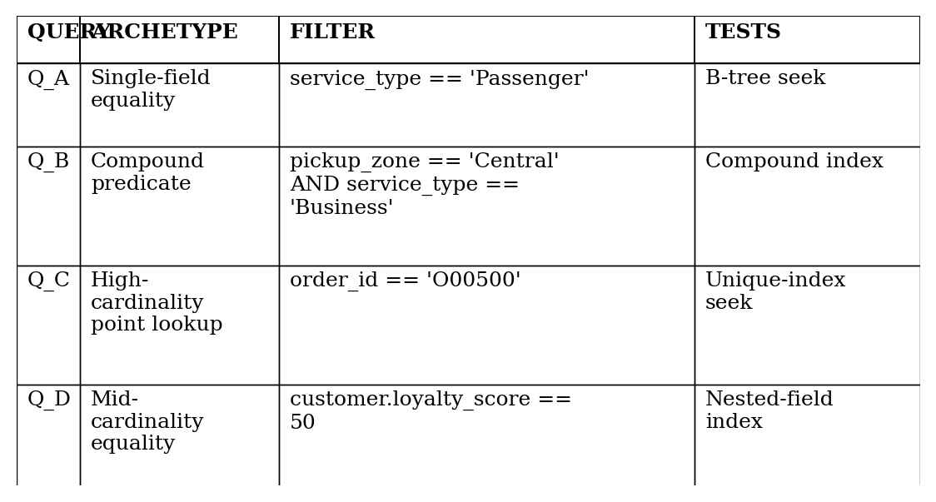
Figure 4: The 4 Query Archetypes Profiled
Figure 4 lists the 4 archetypes I picked and what each one is meant to test. Figure 5 reports the headline measurement: docsExamined before and after, plus the reduction factor and the new winning plan stage.
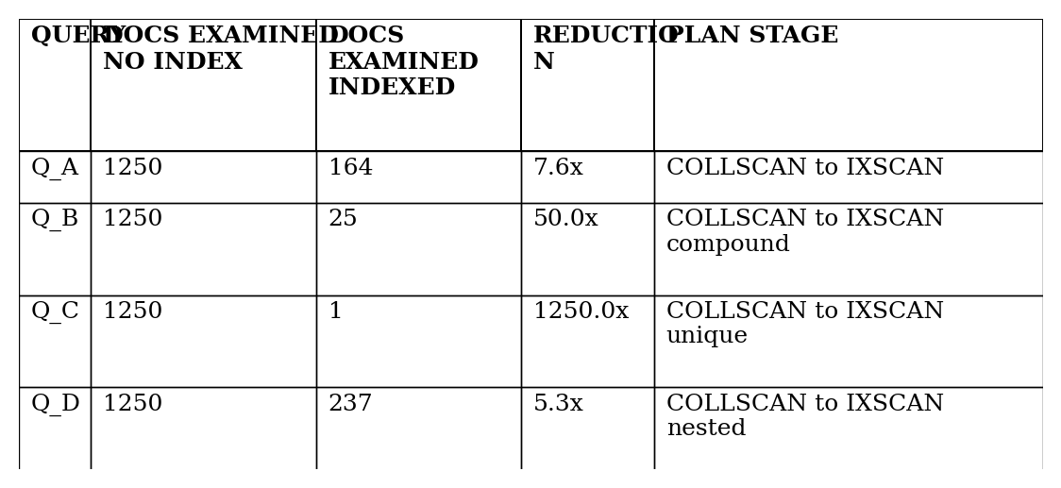
Figure 5: docsExamined Before vs After Indexing, with Reduction Factors
3 patterns jump out of Figure 5. The point lookup on order_id (Q_C) returns 1 document, so its reduction factor is the size of the collection: 1250x. The compound predicate (Q_B) wins 50x because the index narrows on the higher-selectivity field first. The single-field equality (Q_A) and the nested-field equality (Q_D) win 7.6x and 5.3x because each filter cuts the collection to roughly an eighth of its size. All 4 indexed runs end up with IXSCAN as the winning stage; all 4 baselines use COLLSCAN, which is what B-tree theory predicts.
What I cannot report credibly is execution time. The collection fits in RAM, so the engine never actually has to touch disk, and the wall-clock differences between COLLSCAN and IXSCAN are inside the noise floor of millisecond timing. At larger data volumes the same archetypes would surface absolute timing wins, but at this scale docsExamined is the more honest metric to report.
4. Critical Evaluation
3 things bound my experiment. The working set fits in cache, which makes timing uninformative; I leaned on documents-examined as the proxy metric. The 4 archetypes are representative but not exhaustive; range queries, sorted aggregations and $lookup pipelines all hit different planner paths and I did not profile any of them here. And I picked the indexes by hand from inspection of the queries; the Atlas Performance Advisor would surface unused or shadowed indexes I might have missed.
My compound index on (pickup_zone, service_type) is a deliberate choice that depends on the workload assumption. The prefix rule means that index is useless for a service_type-only filter; if my dominant workload ever shifted that way, the index order would be wrong. I sized this as Central-and-North-heavy reporting, so pickup_zone is the higher-selectivity leading field. A workload audit would be the first thing I would run on a real production deployment.
5. Conclusion
4 query archetypes profiled with and without their proposed indexes. Documents examined falls from a full 1250-row scan to between 1 and 237 rows, with reduction factors ranging from 5.3x for the mid-cardinality nested-field equality to 1250x for the unique point lookup. All 4 indexed runs swap COLLSCAN for IXSCAN as the winning stage, which is the qualitative outcome I expected from the B-tree theory. The 5-index recommendation that follows from this experiment is what indexes_explain.py ships, and it is what I have applied to the production configuration of orders_aggregate. A real production rollout should re-run the experiment against representative data volumes before treating the recommendation as final.

